Week 13 - Assignments

# 1. Context Relevancy metrics (RAG Based --LLM As Judge)
Input should be considered
# Input/User Query
# Retrieved Context

Partial Relevant:
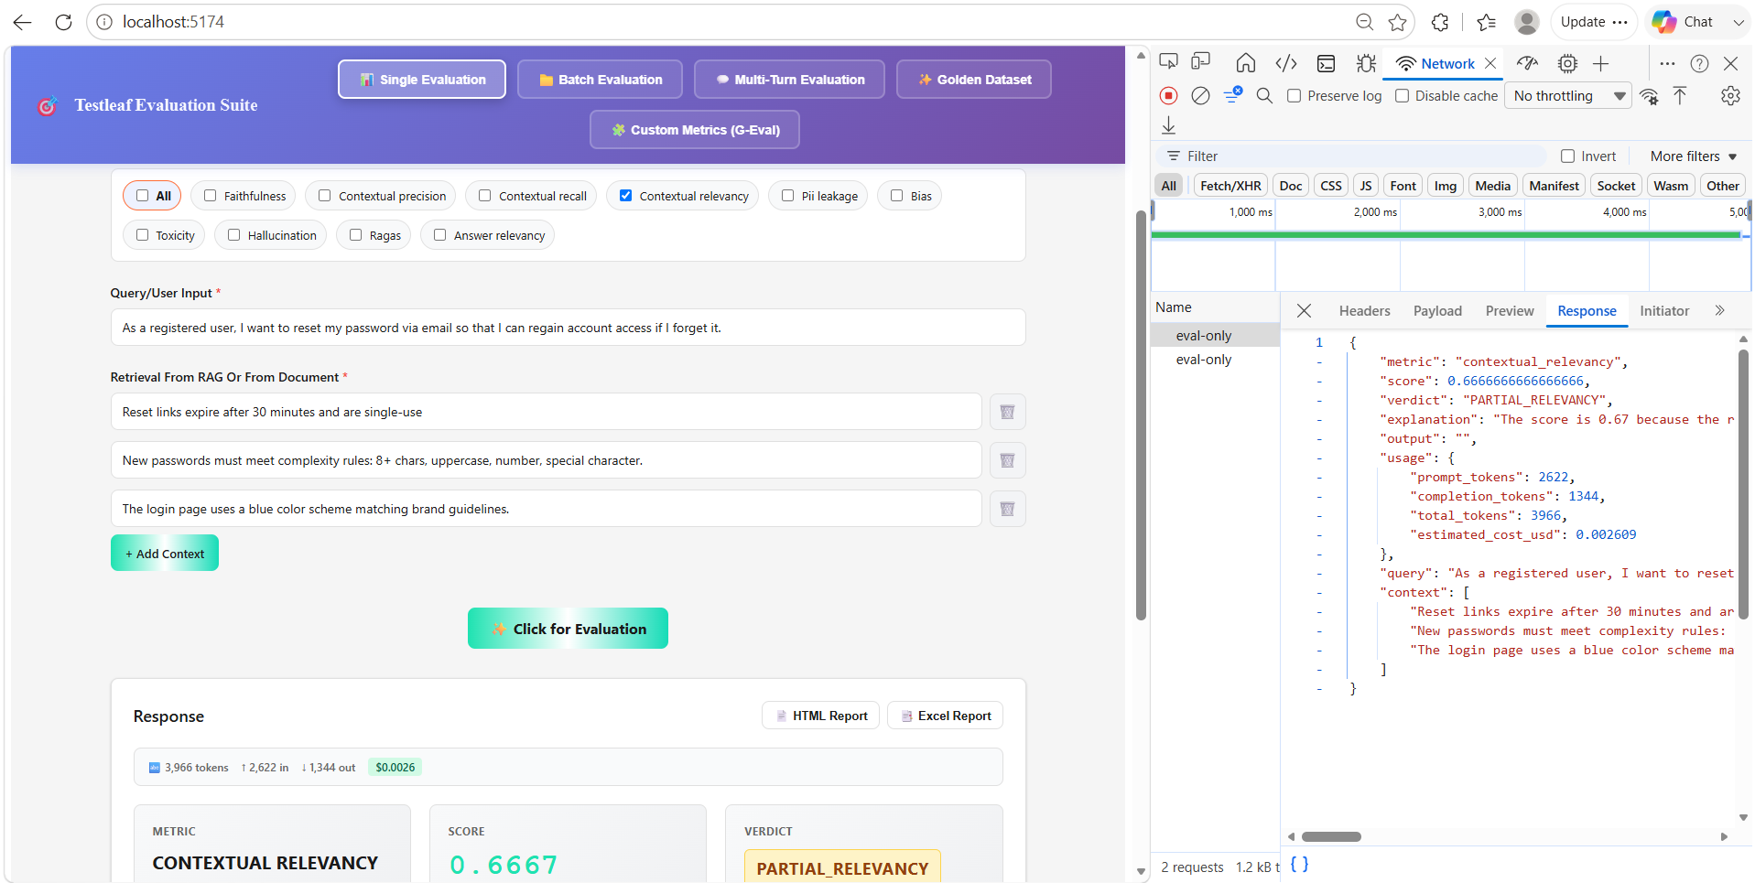

Relevant
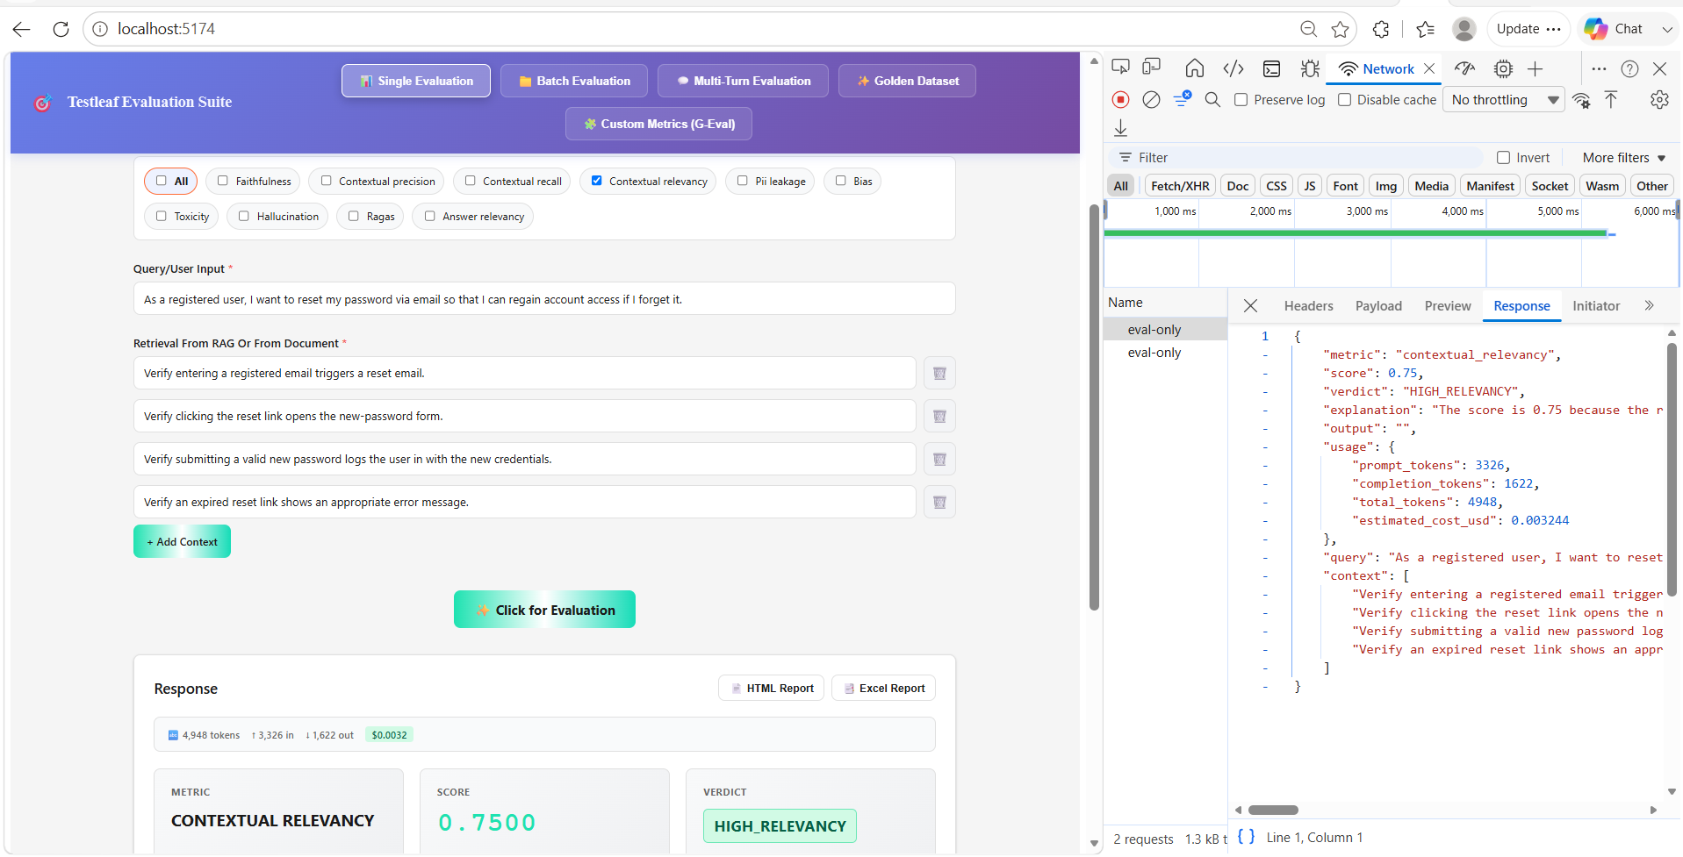

# 2. Exact Match (Non LLM )
# Expected output
# Actual Output

Created
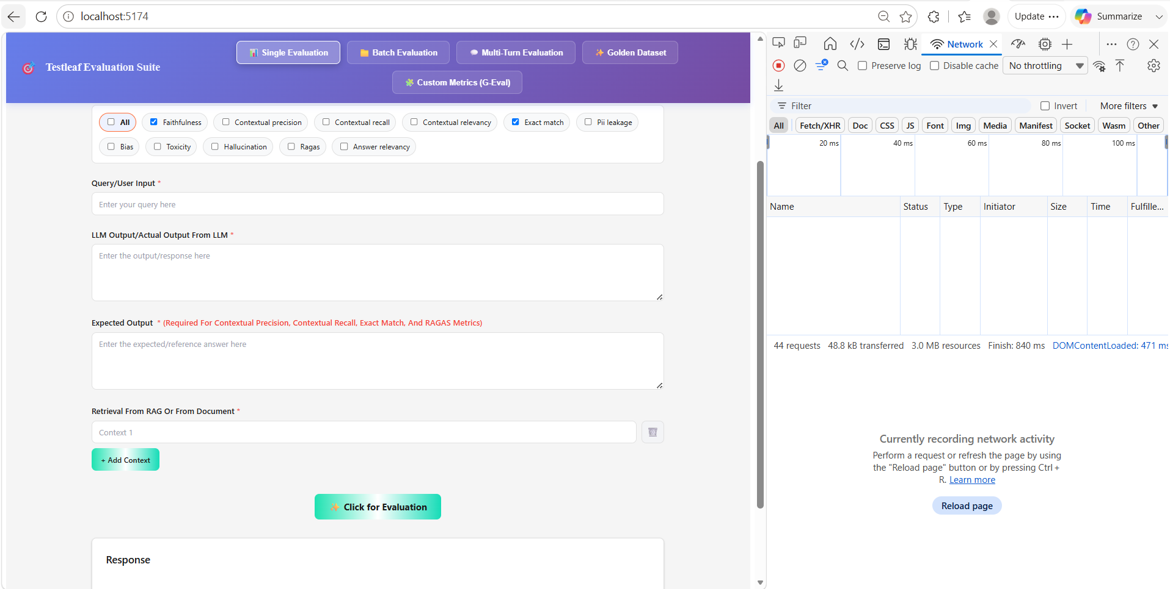

Mismatch
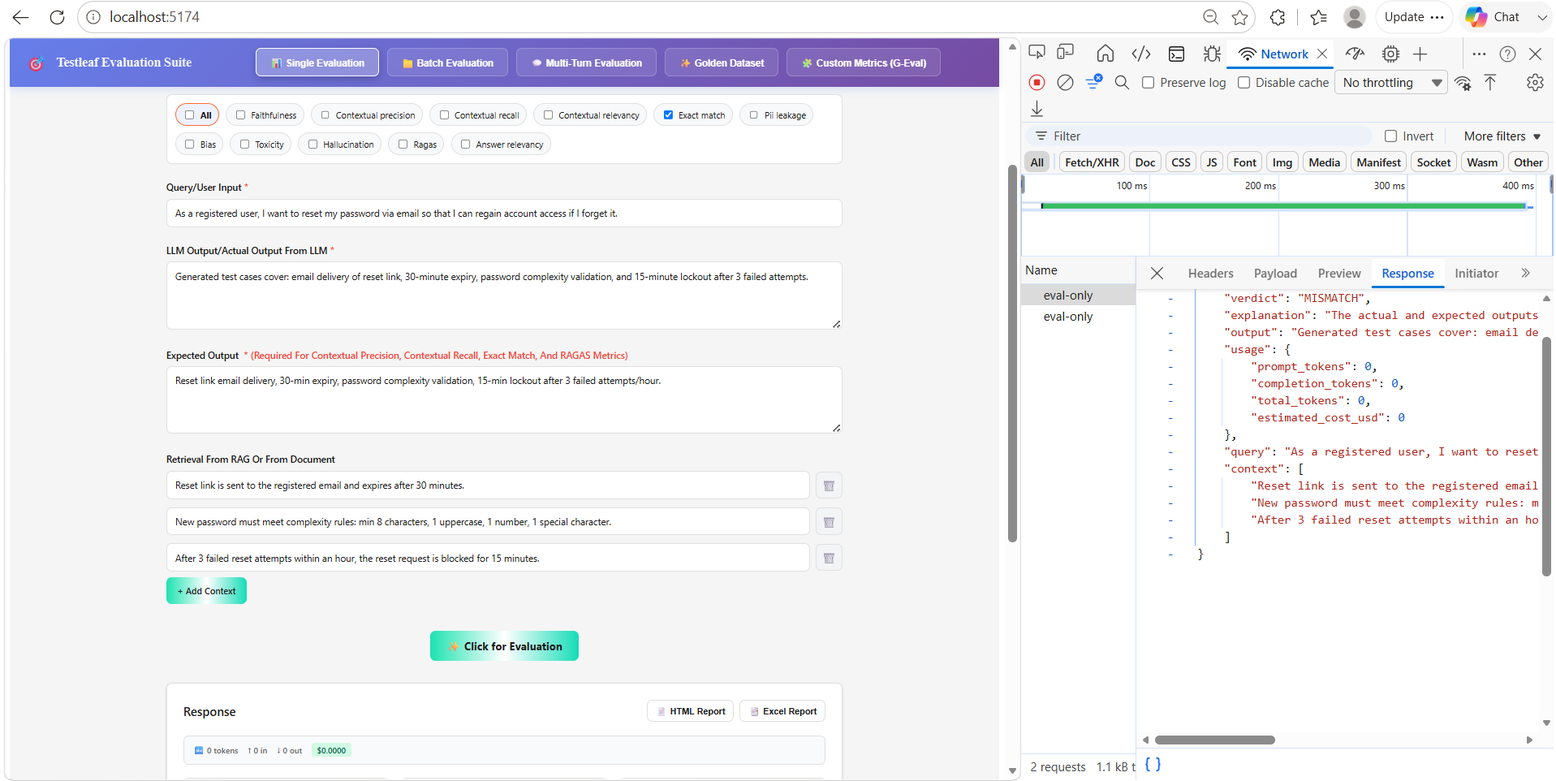

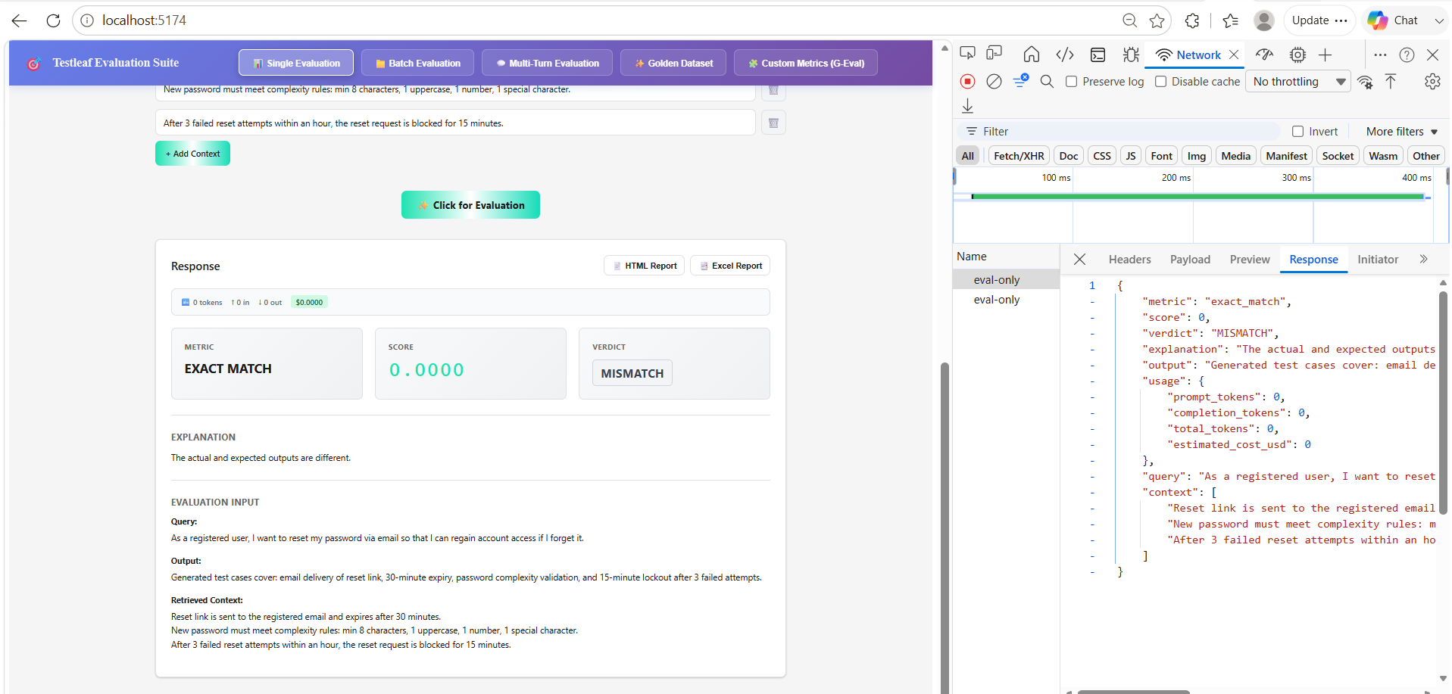

Exact Match
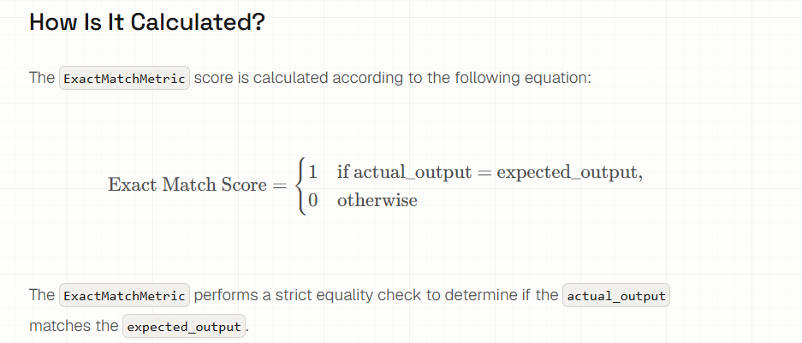
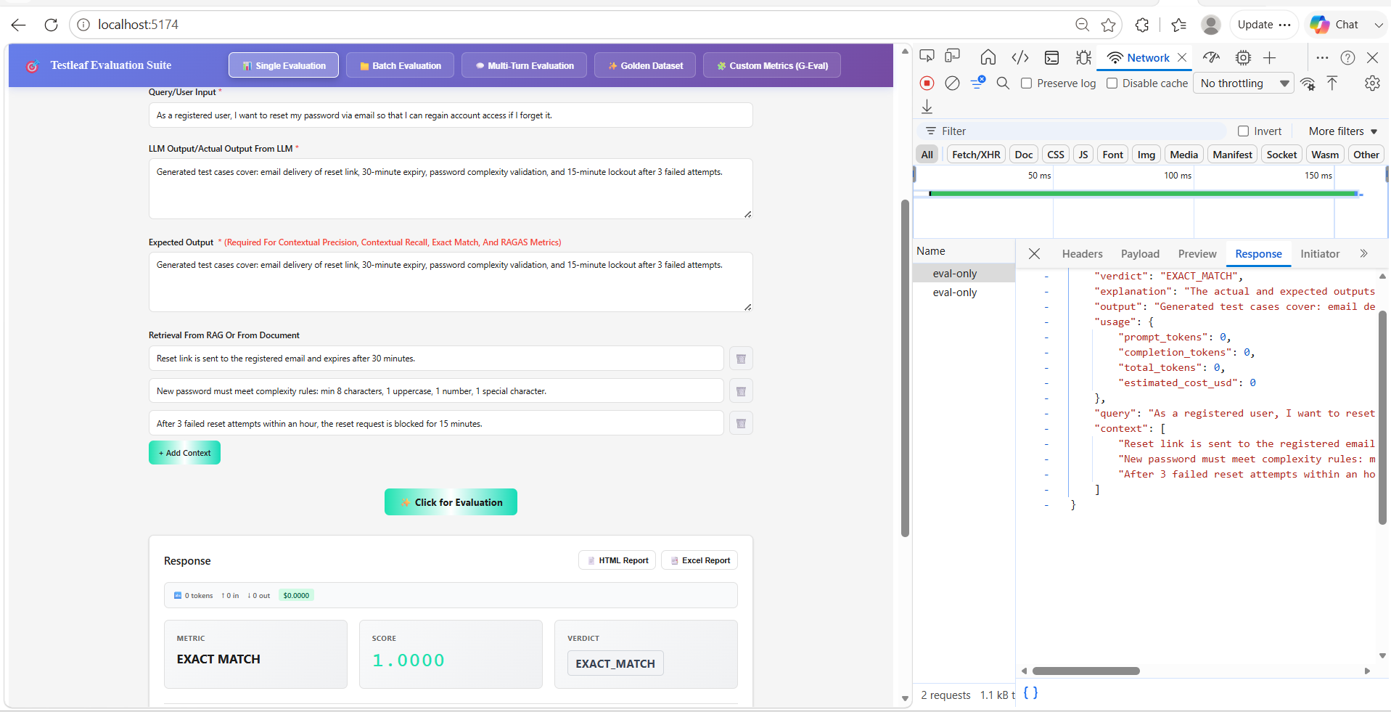

# UI Enhancement
In the Metrics Evaluation Page UI create a Dropdown with MultiSelect to select the metrics and send to Deepeval for Evaluation
